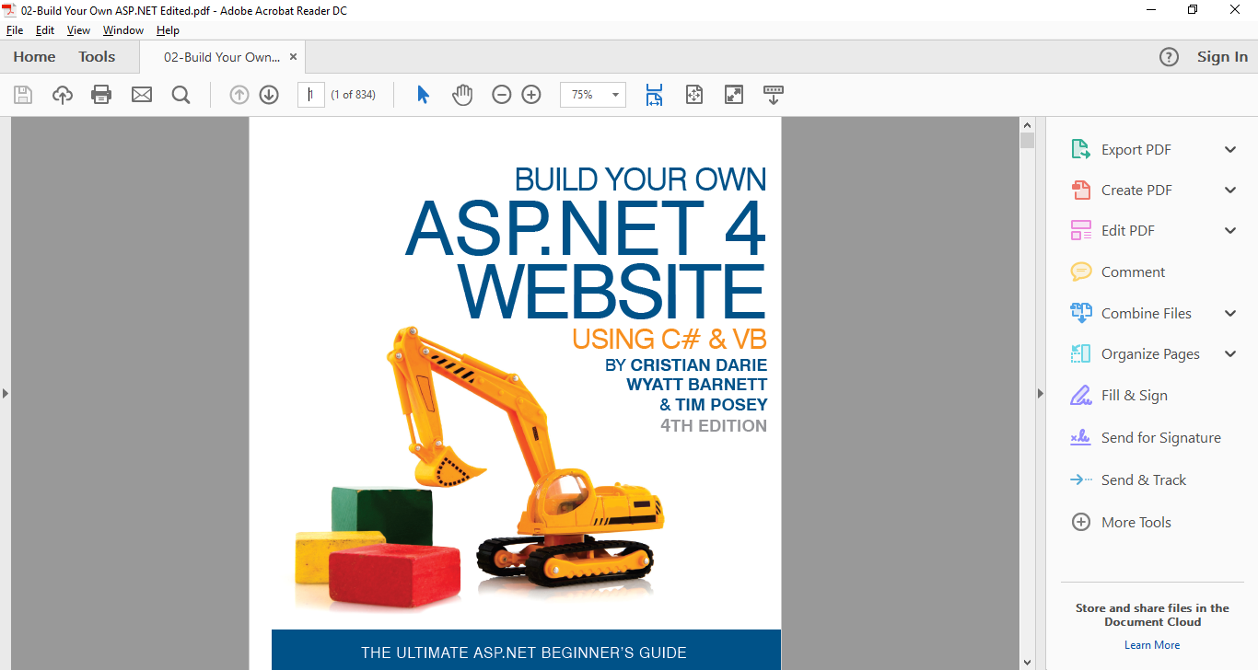

Assignment #03:

COURSE COMP229 Winter 2017

**CENTENNIAL COLLEGE**

Fabio Alexandre Ciconi | 300930989 | 04/03/2017

Contents

1. Provide a Site Map that contains the above site structure. 2
2. Create separate aspx file for each item in the above menu 3
3. Create a App_Themes folder in the Solution Explorer and add Blue as a New Item there (Read the slides, the instructions are there) 4
4. Create a style sheet there and name it Dorknozzle and define an appropriate style in it. 5
5. Define a skin for your Server Control text boxes as the font, forecolor and back color are defined differently from the DEFAULT 6
6. Explain how to connect your skin and your text boxes together 9
7. Explain what is the main difference between CSS and Skin? 9
8. Define a master page that contains header, menu and a content section. Define an appropriate image for the header and the menu items. The master page in the design view should be as follows 10
9. Explain how to hide the root in the menu 10
10. Now it is the time to go to the Help Desk webpage and modify it to be similar to the following image: 11

# Provide a Site Map that contains the above site structure.

a). add two SUBDIRECTORIES to address book:

1. Staff
2. Others

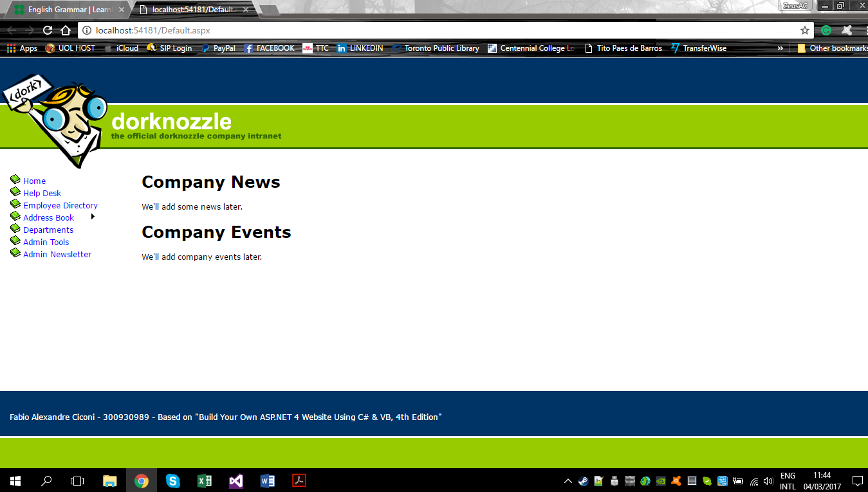

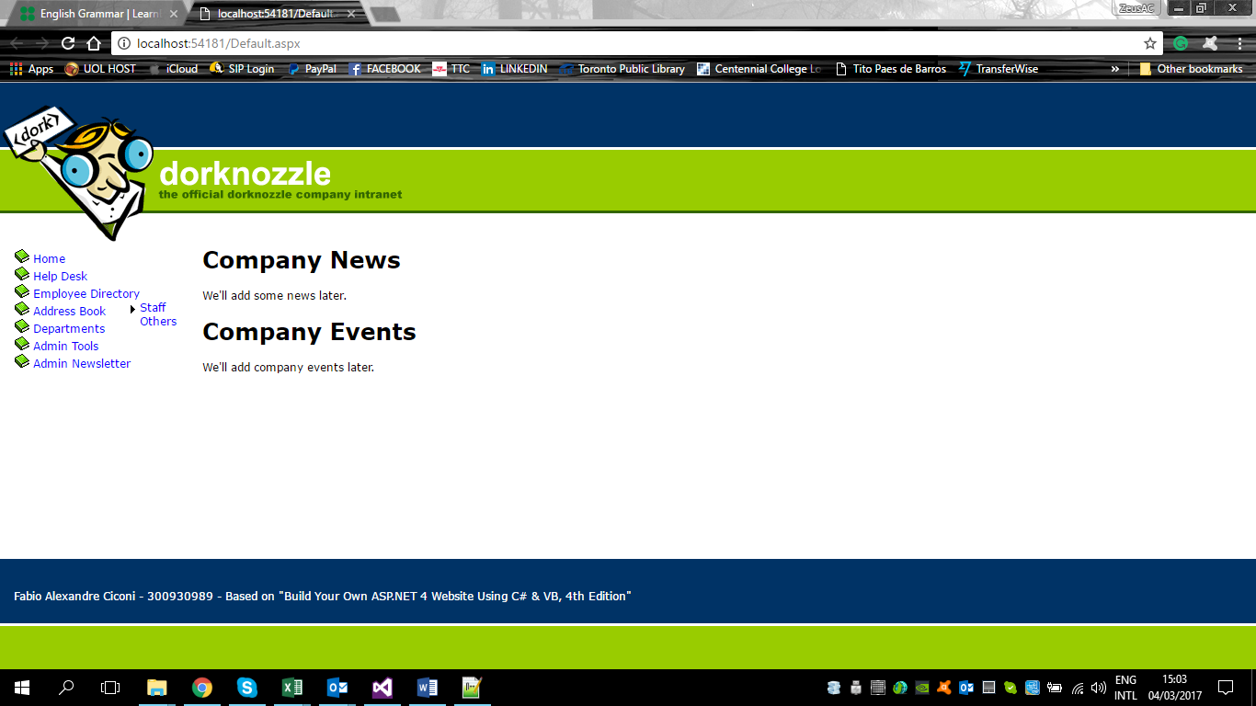

# Create separate aspx file for each item in the above menu

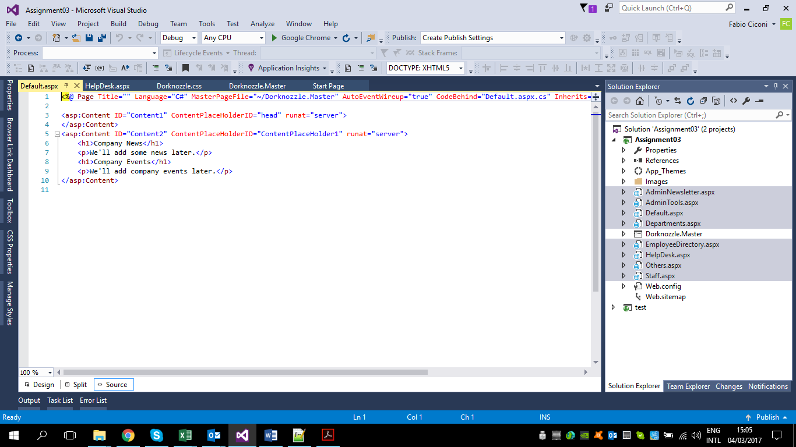

# Create an App_Themes folder in the Solution Explorer and add Blue as a New Item there (Read the slides, the instructions are there)

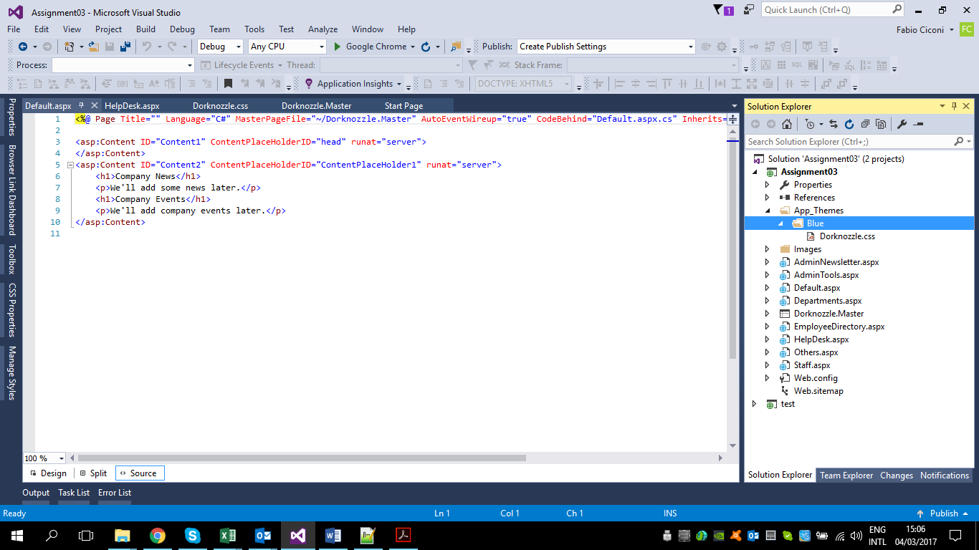

# Create a style sheet there and name it Dorknozzle and define an appropriate style in it.

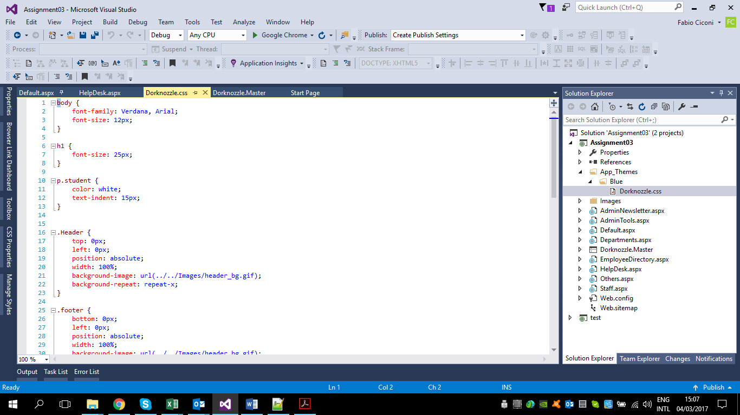

# Define a skin for your Server Control text boxes as the font, forecolor and back color are defined differently from the DEFAULT

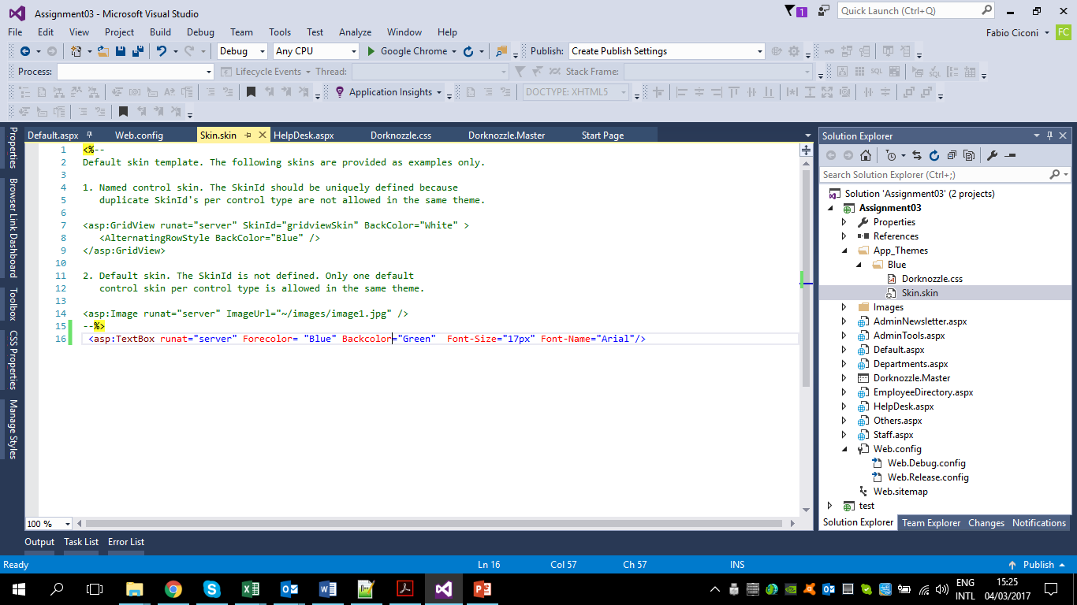

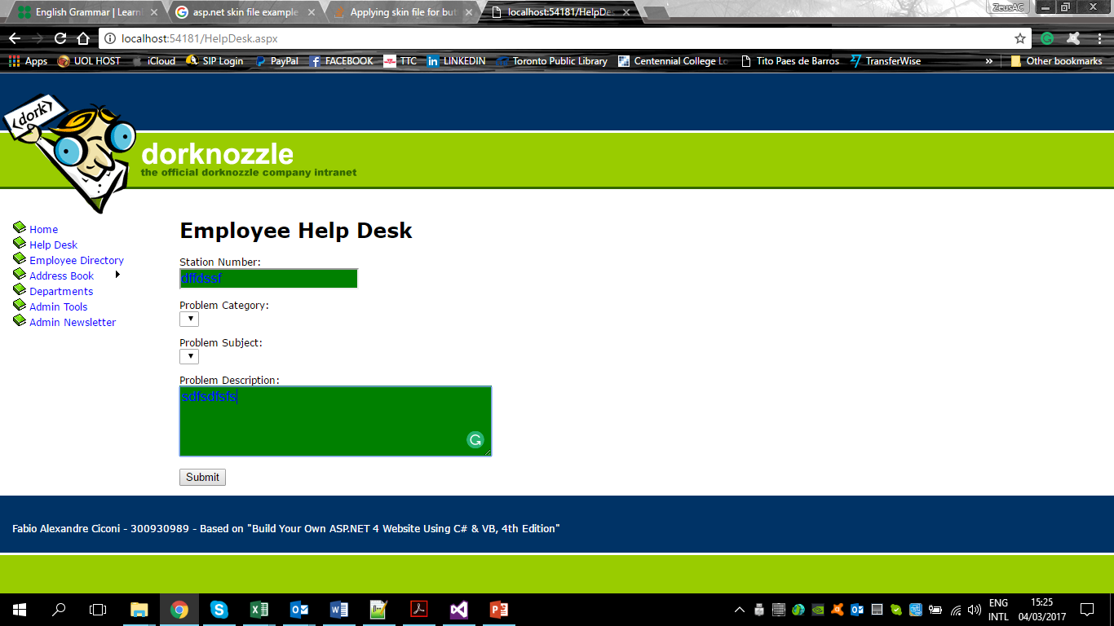

Using SkinID:

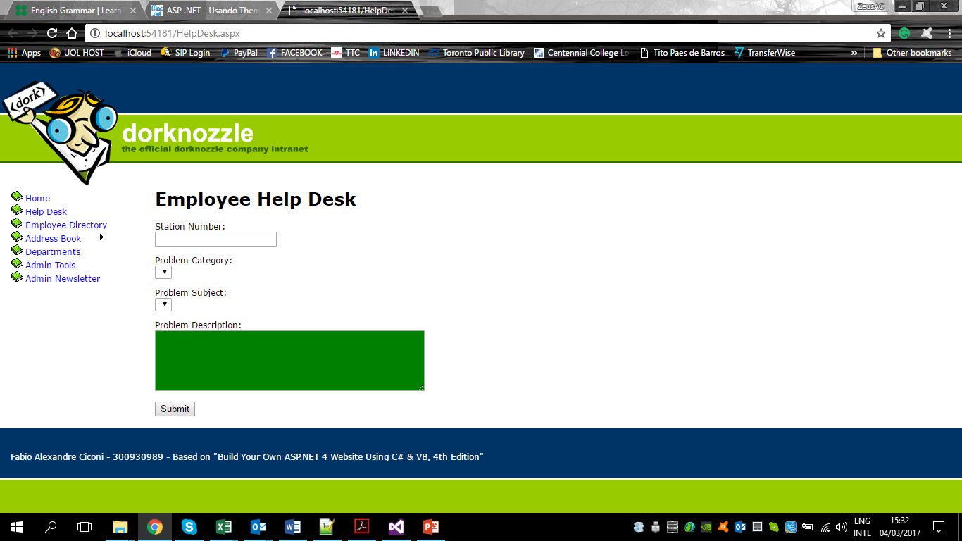

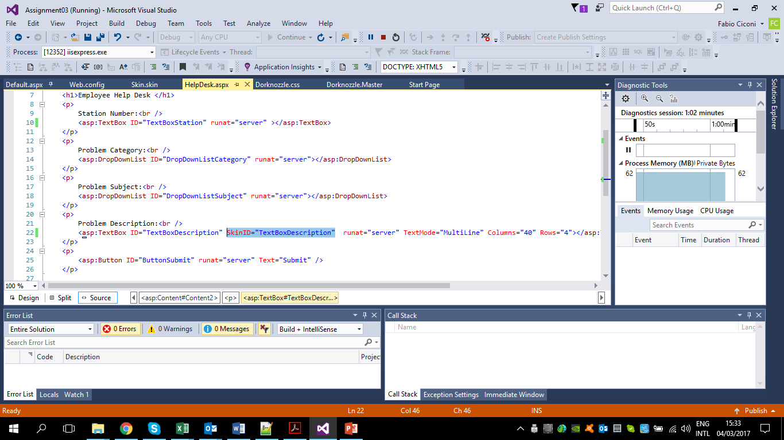

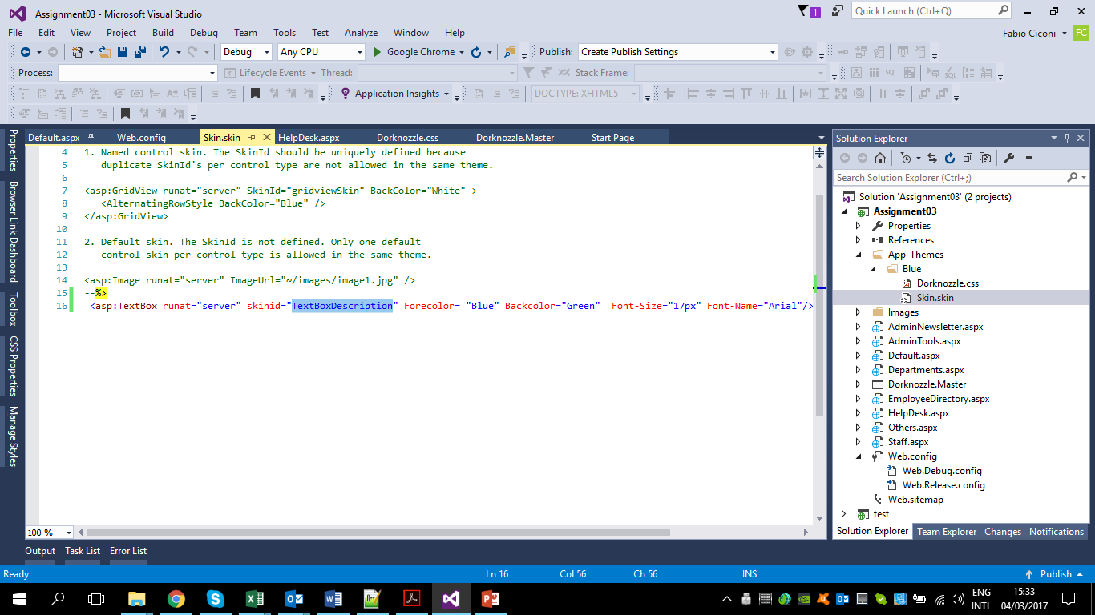

# Explain how to connect your skin and your text boxes together

To connect text box and skin is necessary to write a command in the web config file. If you do not use SkinID command the code on the skin will be applied to all controls.

<asp:TextBox runat="server" Forecolor= "Blue" Backcolor="Green" Font-Size="17px" Font-Name="Arial"/>

All textboxes will be the same attributes above.

# Explain what is the main difference between CSS and Skin?

Skin file can be used on ASP.NET server controls.

CSS is used in HTML elements

Skin is rendered from ISS server is unique for all clients;

CSS is rendered on the client side, so some browsers may present issues;

# Define a master page that contains header, menu and a content section. Define an appropriate image for the header and the menu items. The master page in the design view should be as follows

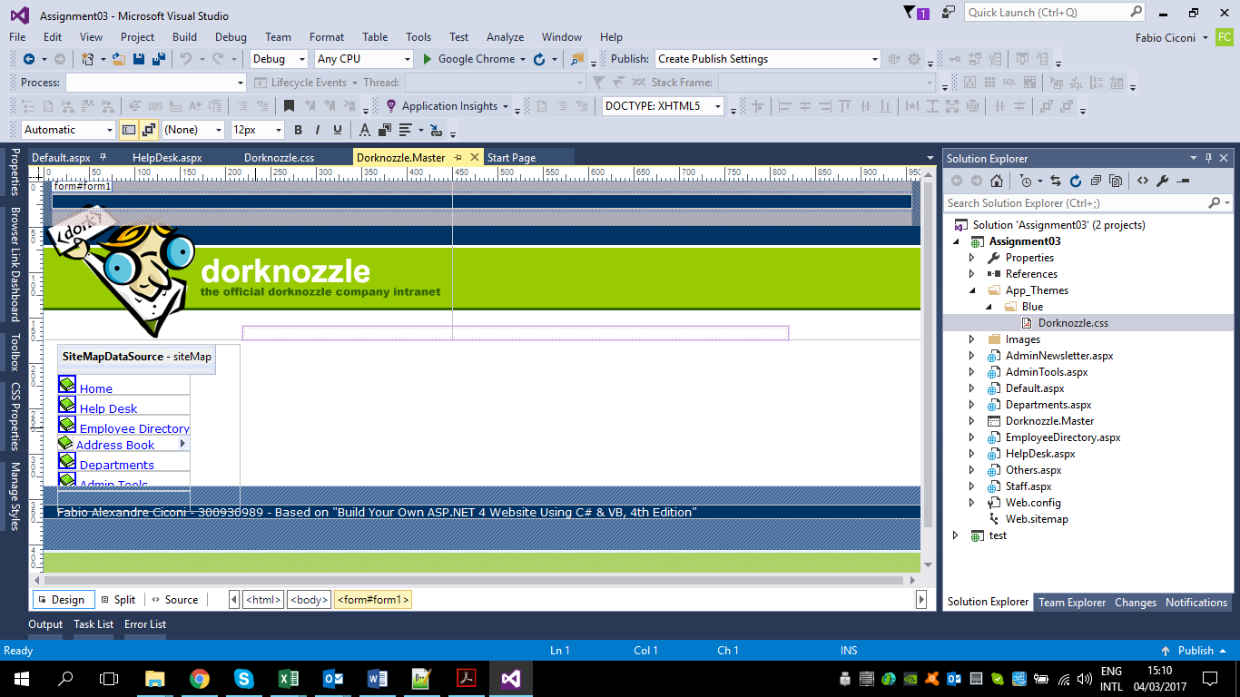

# Explain how to hide the root in the menu

To hide the root menu is used the command ShowStartingNode="False";

# Now it is the time to go to the Help Desk web page and modify it to be similar to the following image:

